Roy Periodontics | 6825 A Parkdale Place, Indpls., IN 46254  317-293-7171  info@royperio.com

3D IMAGE REQUEST
Date: _______________________
Patient’s Name: _______________________________ DOB: ________________
Referring Office: _________________________ Phone Number: _____________
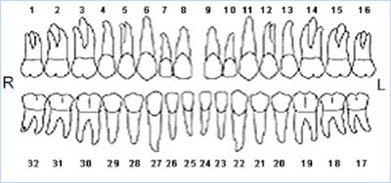
Please circle or mark with an “X” the central area of interest to be scanned.
Additional Notes: __________________________________________________________________________________________________________________________________________________________________________________________________________________________________________________________________________________________________________________________________________
Please fax (317-295-8354) or mail request to our office. Thank you!

